

**Mathematics Specialist**

**Test 1 2016**

**Complex Numbers**

**Resource FREE**

**NAME: _______________________________________________ TEACHER: MLA**

**28 marks 28 minutes**

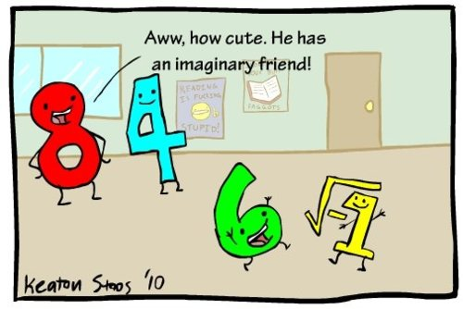

**SCSA formulae sheets may be used in this section**

**Question 1 [3, 2, 2 and 2 = 9 marks]**

Represent the following regions on separate Argand diagrams:

(a) $Im\left(z\right)≤2Re\left(z\right)+1 ∩ 1≤ Im(z)<2$

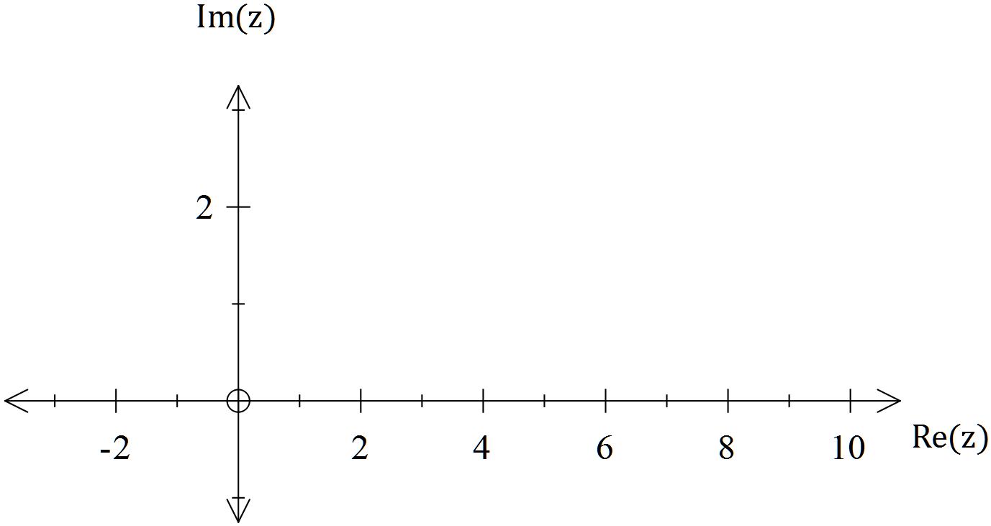

(b) $\arg\left(z-3i\right)=arg⁡(z+3$) + $π$

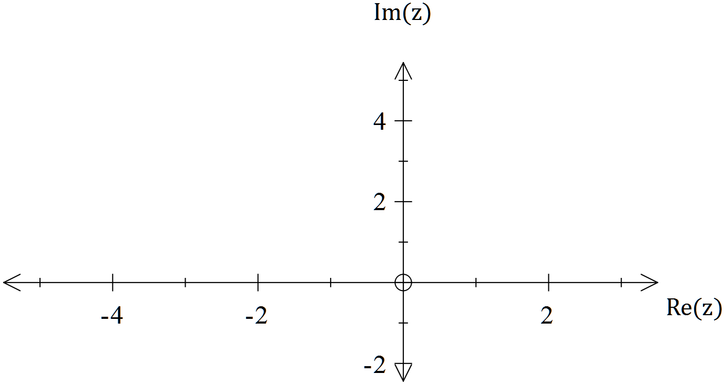

(c) $\left|z\right|=arg⁡(z)$

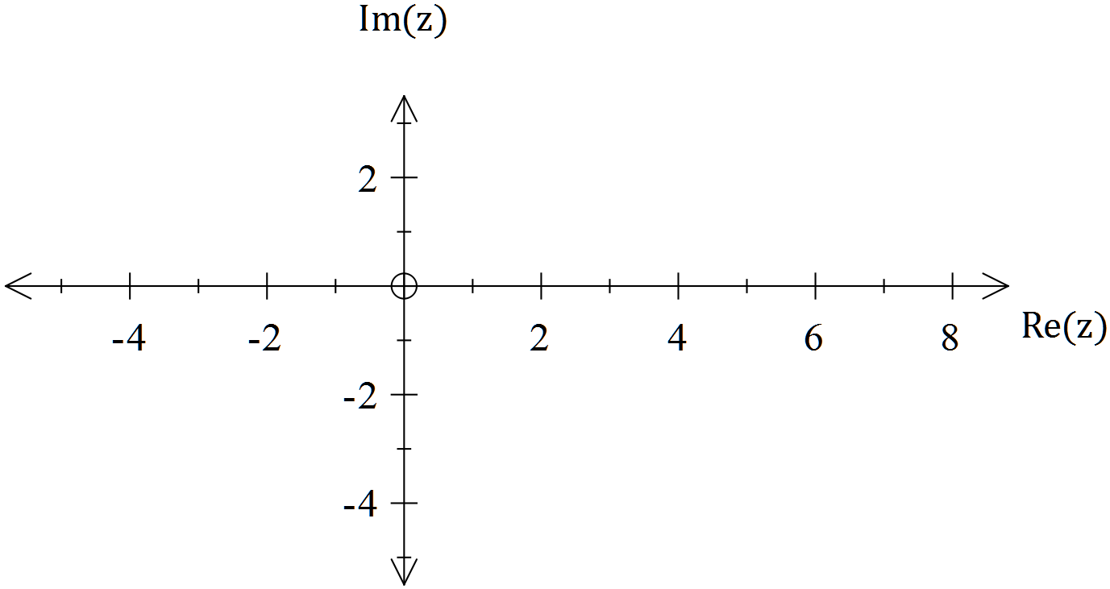

(d) $\left| (z-\left(3+i\right) \right|+\left| z+2-i \right|=5$

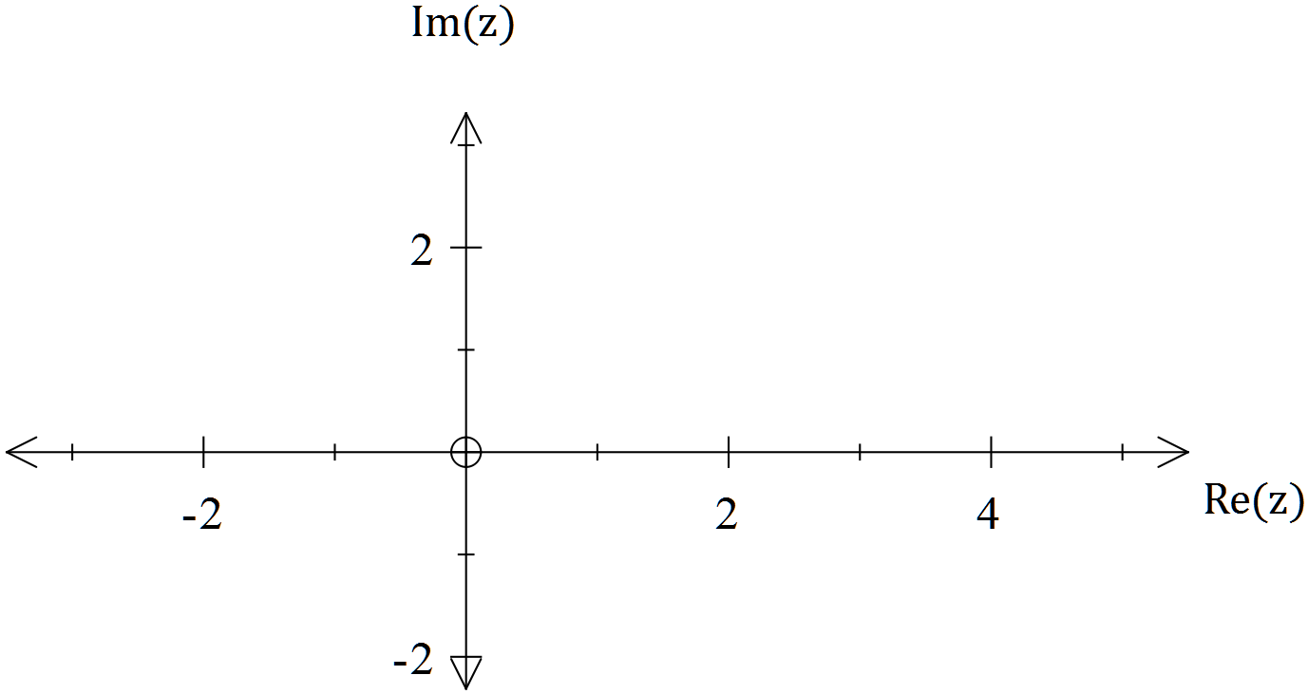

**Question 2 [3, 2 & 3 = 8 marks]**

(a) If $z=r cis\left(α\right) , prove that z^{-1}=\frac{\overline{z}}{r^{2}}$

(b) Show that $cos\left(θ\right)-isin\left(θ\right)=cis(-θ)$

(c) Express $z+\overline{z}=(z)(\overline{z})$ in Cartesian form. Describe the locus of z.

**Question 3 [3 & 2 = 5 marks]**

(a) Use de Moivre’s theorem to solve ${ z}^{3}=-8,$ leaving answers in polar form.

(b) Determine the exact area of the polygon whose vertices are the solutions found above.

**Question 4 [6 marks]**

Consider the identities $z^{n}+\frac{1}{z^{n}}=2 cos\left(nθ\right)$ and ${ z}^{n}-\frac{1}{z^{n}}=2i sin(nθ)$.

Use one or both of these identities to prove that $6\sin\left(2θ\right)+3\sin\left(4θ\right)=12\sin\left(2θ\right)\cos^{2}(θ)$.

End of Section 1



**Mathematics Specialist**

**Test 1 2016**

**Complex Numbers**

**Resource RICH**

**NAME: _______________________________________________ TEACHER: MLA**

**22 marks 22 minutes**

[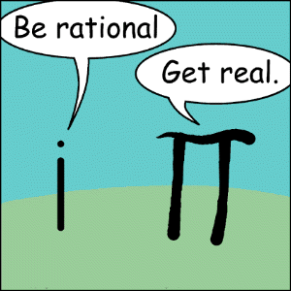](http://www.google.com.au/url?sa=i&rct=j&q=&esrc=s&frm=1&source=images&cd=&cad=rja&uact=8&ved=0CAcQjRw&url=http://lcmaths.weebly.com/complex-numbers.html&ei=D_uIVa3SNcrp8AWdspCoAQ&bvm=bv.96339352,d.dGc&psig=AFQjCNF9Sy89pGnFVkzzP2fW8GWr5xIZ4g&ust=1435126643393504)

**SCSA formulae sheets, ClassPads and a single A4 sheet of notes may be used in this section**

**Clear working must be shown in order to be awarded full marks**

**Question 5 [3 & 3 = 6 marks]**

(a) The polynomial $2x^{3}+bx^{2}+c$ has a factor $\left(x+1\right)$ and leaves a remainder of 16 when it is divided by $(x-3)$. Find the values of b and c.

(b) If ${(x-a)}^{2} is a factor of the real polynomial f(x), then \left(x-a\right)$ is a factor of $f '(x)$, where $f '(x)$ is the derivative of $f(x)$ with respect to x.

Knowing this, if ${(x+2)}^{2} is a factor of$ $2x^{4}+bx^{3}+cx^{2}-4$, determine the values of b and c.

**Question 6 [2, 1, 2 = 5 marks}**

For $\left\{z:\left|z+5-2i\right|=2\right\}$, determine:

1. The exact maximum possible value of $\left|z\right|$

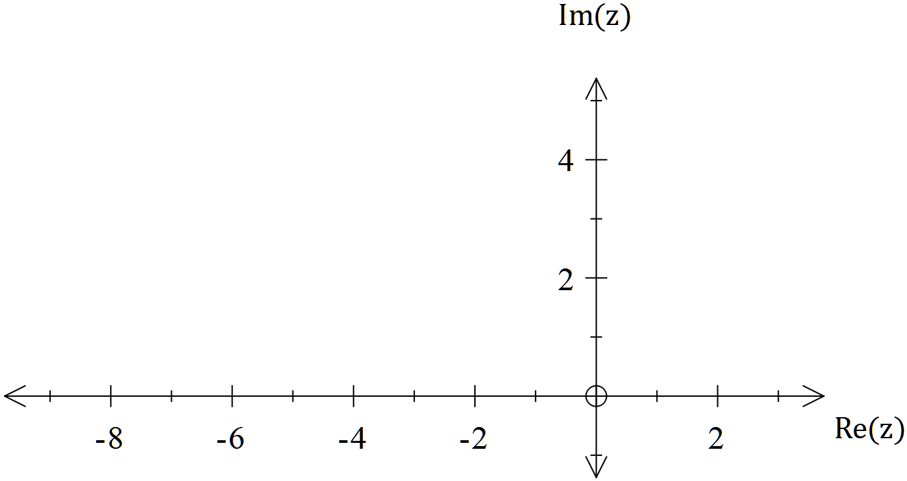

1. The maximum possible value of $arg⁡(z)$
2. The minimum possible value of $arg⁡(z)$, correct to 1 decimal place.

**Question 7 [4 & 1 = 5 marks]**

(a) Determine the Cartesian equation represented by $\left\{z:\left|z-(10+5i)\right|=3 \left|z-(2-3i)\right|\right\}$

(b) Sketch the locus defined in (a)

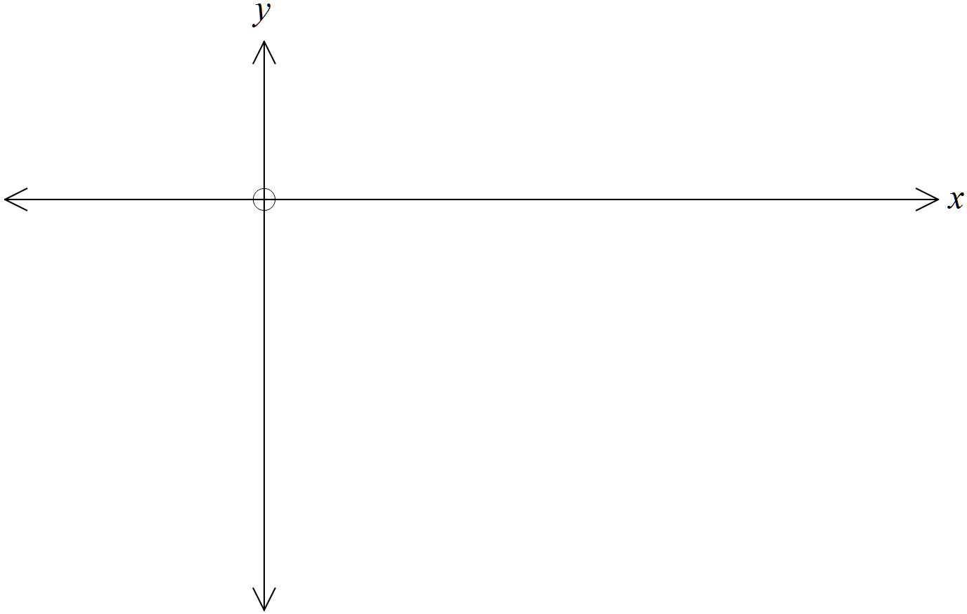

**Question 8 [6 marks]**

Solve $z^{3}+{(1+i)z}^{2}+\left(2+i\right)z+2=0$, $∀z∈$ C, leaving answers in exact form.

End of Section 2